COMP 472 Project One Report, Indonesian Puzzle
Hongbo Liu, Thanh Tung Nguyen
¹ 29566228 hongboliu8806@gmail.com
² 40042891 nguyenthanhtung2605@gmail.com

- Introduction
  - Purpose
This purpose of this report is to compare to explore different types of search algorithms to solve a game called “Indonesian Puzzle”. The algorithms that were used are namely, Depth-First Search, Best-First Search and A*, ranked from least “complex” to most.

  - Technical Details
Part one of this project has already been submitted and demoed. It involved implementing a simple Depth-First Search algorithm to compute the path of the solution. The technical complexity of that task was fairly straight-forward and was implemented using recursion. One of the interesting point that had to be taken into consideration was the fact that the search algorithm would terminate once the max depth limit is reached. This might cause the program to exit prematurely even though a viable solution exists due to the fact that if a node that leads to a solution is explore near the depth limit and was forcefully abandoned due to the depth constraint, and that this node has been added to the closed list, this particular node will never be visited again even if it will be reached with a lower depth value from an alternative path. This can be solved by storing each node and its last visited depth using a hashmap. If this node is later being evaluated at a lower depth, then it will be visited and its depth value updated in the hashmap.
The other two algorithms operate almost exactly the same. The actual implementation resembles to a Breath-First Search by using queues to store all the nodes to be visited. The same heuristic calculation is used for both methods and will be discussed further in details in later sections. As for the source code, many helper methods are stored in the helper.py class for better code clarity.
- Heuristics Discussion
  - Overall Approach
The heuristic calculation is fairly simple for this project. Two main variables are being considered when computing this value. The first one is a method called “get_num_zero()” which takes in the current state of the board and outputs the number of 0’s it has. The second one is a method called “get_connected_islands_count()” which takes in the current state of the board and calculate the number of isolated islands that the board has. The goal is to minimize the values for promising boards that could potentially lead to a solution since a priority queue has been implemented to always pop the lowest value. It is important to note that the value calculated is simply a form of reference for comparison purpose. It doesn’t carry any intrinsic meaning such as the remaining steps to take before arriving at the goal. This is because the nature of this game is rather complex and predicting the number of steps required to finish the game can be very complex and potentially out of scope for this project.

  - Number of 0’s
This feature is very straight-forward. A loop is used to iterate the board and count the number of 0’s in it after touching or flipping a specific dot. This is very easy to implement and only requires O(n) in terms of time complexity. This is also similar to the Hamming distance method since we are only concerned with “out of place” dots that are on the board. Generally speaking, this will lead us towards the solution most of the time. It is cheap to compute and overall effective at advancing the game.
The short comings of this feature is that it’s overly simplified. Maximizing the number of 0’s might sound rational but might not always be the most optimal path towards finding the solution. In fact, in certain scenarios, it is required to “make sacrifices” in order to arrive at a goal. A similar parallel can be drawn by using the game of Chess. In certain situations, it is strategic to sacrifice certain pieces in order to setup a play. But this will contradict with the Hamming distance approach that is used here. A solution might require an intermediate step to decrease the number of 0’s on the board but this step will have a lower priority compared to others and won’t be visited until “better alternatives” have all been exhausted.

  - Number of connected islands
This feature is computed by calculating the number of connected islands on the board. A connected island is a set of points that are connected either horizontally or vertically. The time complexity of this feature is O(n) and is also quite inexpensive to calculate since essentially, it is simply a modified version of a Depth-First Search. This approach makes sense because we want to prioritize boards that have a bunch of clustered dots so that future touches or clicks will also be more rewarding. This feature complements the first one because we were only concerned with the immediate result after touching a dot whereas here we are making assumptions for the future. Because more clustered boards will be faster to solve.
On the other hand, this is only an abstraction of evaluating future moves. Connected islands aren’t always easier to flip in the sense that some shapes might actually take many steps or sometimes impossible to convert. Take a “L” shaped island with no other “1”s on the board for instance, it will compute to a better heuristic in comparison to 3 isolated “+”s but the latter is much more promising. Furthermore, an island that is zig-zagged but somehow connected will also give better heuristic but is a rather terrible candidate node to explore.
A more advanced approach would to analyze the shapes formed by dots on the board more closely. For instance, we know that “+” are great because one click will flip all 5 dots to “0”. Therefore, boards with more “+” should be favored. But this is much more complex to identify and hard to implement.

- Challenges
There weren’t really any big challenges that we’ve faced while doing this project. Initially we had a very modular coding infrastructure in mind so added new algorithms were very easy and effortless. There were some minor bugs that we have faced that we have spent quite a bit of time to identify and solve.
For example, the values from the number of “0” calculation were supposed to be deducted from the overall heuristic values, but we have added it instead. This has caused Best-First Search and A* Search to undertook significantly longer solution paths. Furthermore, our A* algorithm was actually performing worse than Best-First Search and it took some experimentations to figure out what was going on and to fix it.

- Analysis
  - General Overview
Amongst the 3 algorithms tested, Depth-First Search is undoubtably the worst performer as shown on Figure 1. It had no problem solving 3x3 and 4x4 puzzles but wasn’t able to compute any reasonable difficult 5x5 and 6x6. The program simply enters a state where there are just too many paths to mindless explore. Best-First Search and A* used the same heuristic calculations and performed much better compared to the uninformed method. This is not surprising because increasing the puzzle size will also cause the overall time complexity to resolve the puzzle exponentially. It is simply not a viable solution to explore all possible paths in the worst case to find the solution. And this is why the two informed search algorithms were able to solve the provided puzzles with relative ease. On the other hand, implementing heuristics require a deep understanding of the underlying problem. If we are dealing with smaller puzzles such as 3x3, Depth-First Search is often good enough to get the job done.

  - Number of “0”s and islands
Since we have already established the importance of using heuristics when dealing with huge search space, the quality or accuracy of the features being taken into account becomes the major contributing factor in determining whether the algorithm works or not. That being said, in order test whether a particular feature is actually helping, we have tested them one by one to see if there’s any gain in performance in comparison to a scenario where heuristics aren’t used at all. As a result, both calculating the number of “0”s and number of islands are working as intended.
It is however interesting to point out that some features are more “useful” than others. For instance, counting the number of “0”s will always yield a result whereas counting the number of islands often will not find the solution before hitting the constraints. Consequently, the first feature was assigned a higher weight using a multiplier of 2. However, adding the second feature had no impact on the Best-First Search algorithm. A possible explanation might be the fact that counting the number of “0”s is already a highly efficient way to estimate heuristics and is somehow incorporating or shadowing the result gotten from the latter feature. In other words, these two features might be highly positively correlated and adding the second feature is similar to adding a proportional constant to the value calculated from the first feature. Same thing applies for A*. Initially the number of paths did increase when adding the second heuristic to the mix, but it was soon discovered that the reason for that performance increase is due to the fact that h(n) was under-represented and needed a higher weight. Therefore, adding a feature that’s highly correlated than an existing one is effectively equivalent to increasing the overall weight of h(n). It is also possible that the second feature simply doesn’t offer much meaning for smaller n’s such as 3,4 and even 6. Results might be different for larger boards but we haven’t had the time to test it out.
Another potential feature that could be implemented is counting the distances between dots. In other words, we want to select boards that have dots closer to each other. This could potentially be done by calculating the standard deviation of each board. However, due to time constraint, we didn’t have the time to explore this feature.

  - g(n)
A noticeable increase in performance is observed when switching to A* from Best-First Search. This is not 100% true across the board but the minor inconsistencies can be ignored from a statistical perspective, eg: 11 vs 13 steps. The assumption is that if a path has taken many steps and long time to be explored and still hasn’t yielded result, it is preferable to start exploring other paths. This is essentially an optimized Best-First Search and allows the algorithm to also consider sunk costs. This is important because the heuristics that are being used is really only concerned with the immediate future since the usefulness of counting the number of islands hasn’t been proven yet as a conclusion that was drawn from previous sections. Therefore if the algorithm is only ever concerned about whether the number of “0”s are decreasing, this would make both Best-First Search and A* behave somewhat like Depth-First Search in the sense that once a node is been selected for exploration, for instance node A amongst its cousins B, C, D, the algorithm would never back track and explore B, C, D unless we can no longer advance further on the path that originated from A. This is because no matter how terrible the formation of the board of A’s children are, they are most likely to have lower number of “0”s compared to B, C and D simply because nodes on the path of A are more developed. That being said, taking into consideration of actual cost of reaching a node is a great alternative than setting a depth limit because we aren’t completely discarding a path. Instead, path A is put on hold until other alternatives have been evaluated to be even less favorable.

  - Conclusion
It is important to know that heuristics can greatly improve the performance of various search algorithms, but the worst case is still unbound. In other words, in many cases, the performance boost can be highly inconsistent. For boards that are “easy” such as a 4x4 puzzle “1101110111011011” where the puzzle was generated by touching an all “0”s board a few times, the heuristics would work very well since most “1”s can be easily converted to “0”s just by touching certain dots once. Whereas other boards may take significantly more effort to solve even with the help of heuristics.
- Figures and graphs

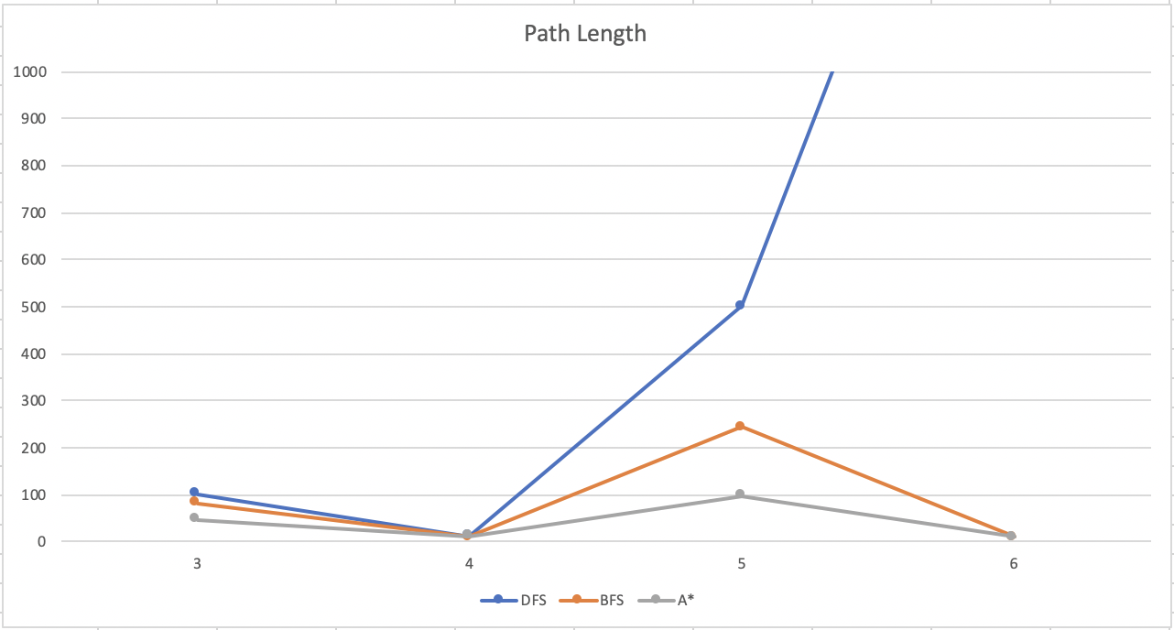
Figure 1: Different algorithms and their performances for various board sizes

